HCG FOUNDATION: PROPOSAL FOR AASHA DAAN-PATIENT AID PROGRAM

PROJECT OVERVIEW:
Project Name: | AASHA DAAN (The Gift of Hope)
Project Title: | Patient Aid Program- Financial Support to Underprivileged Cancer Patient
Submitted to: | ABB
NGO Name | HCG Foundation
Contact Person | Mr. Feros Khan
Phone number | 9986929057
Correspondence address | No. 3 Ground Floor, Tower Block, Unity Buildings Complex, Mission Road District: Bangalore, State Karnataka  PIN: 560027  Phone number with S.T.D. code: 080 – 46607760
Proposed location | Our guiding principle is to never turn our backs on the needy. The patients will be helped at Pan India HCG Hospitals.
Proposed Budget | 2 crores
Thematic Area | Healthcare

- Organizational Profile:
- Name of the organization (As per Registration) | HCG Foundation
- Registered Address | No. 3 ground floor ,Unity Building complex, mission road, Bangalore-560027
- Correspondence Address | No. 3 ground floor ,Unity Building complex, mission road, Bangalore-560027
- Website | https://www.hcgfoundation.org/
- Contact Person | Mr. Feros Khan
- Mobile number | +91-9986929057
- Email Address | feros@hcgel.com

- Legal and Registration Status:
- Date of registration | 04-12-2006
- Registration Type | Trust
- PAN | AAATH6254R
- TAN (if applicable) | BLRH03304A
- GST (if applicable) | NA
- Tax Exemption Certificate | 12A
- Tax Exemption Certificate | 80G
- Acknowledgment of Income Tax return along with IT Return filled | To be attached/To be provided upon request
- CSR Registration Number | CSR00030677
- Registration under FCRA 2010 | Date of Registration | 04-11-2023
- Registration under FCRA 2010 | Registration number | 094421886
- Darpan Registration | Date of Registration | 03-07-2018
- Darpan Registration | Registration number | KA/2017/0162762

- Details about Trustees of the organization:

Name | Designation | Appointment date
DR.B.S.AJAIKUMAR | Managing Trustee | 04.12.2006
ANJALI AJAIKUMAR ROSSI | Trustee | 22.02.2021
DR.GANESH NAYAK | Trustee | 04.12.2006
DR.RAMESH S BILIMAGGA | Trustee | 22.02.2021
SATHISH SHENOY | Trustee | 04.12.2006

- Previous Partners/Donor agencies of the organization:

- Merck Pharmaceuticals
- ABB
- CVC
- Child Help Foundation
- Child Vikas foundation
- CVC Capital Partners
- Prestige Group
- Sarojini Damodaran
- NES
- Go colors

- Organizational Background: (Organization profile, vision & mission, work profile, locations the organization works at and key areas of impact and area of operation of the organization):

HCG Foundation is a unique not-for-profit organization that raises funds through donations, grants, and CSR funds to help economically marginalized patients, raise awareness about cancer and its prevention, and conduct cancer early detection camps. HCG Foundation was constituted and registered as a Public Charitable Trust on 4th December 2006 with the single-minded aim of improving the quality of life of patients by empowering them to avail the best cancer care that medical science can offer. It has helped over 4,120 patients and conducted more than 482 awareness camps since its inception catering to 52,000 beneficiaries.
Vision: -
Ensuring access to quality cancer treatment for those in need and creating awareness on Cancer and its Prevention

Mission: -
- Provide financial support to those who cannot afford cancer treatment.
- Spread awareness on cancer and cure.
- Make early detection service more accessible for rural communities.
- Educate on healthy lifestyle habits and prevention of cancer.
- Provide psychological support to the family of cancer affected.
- Sponsor, promote and conduct research activities towards prevention, treatment and eradication of cancer.

- Awards and Recognition (if any)
- Awarded to HCG Foundation: Bengaluru NGO’s Leadership Award 2017
- Certificate of Merit Awarded to HCG Foundation: National CSR Leadership Certificate of merit 2016.

Section 2: Project Proposal

- Project Identification details-

- Project Name | AASHA DAAN
- Project Title | Patient Aid Program-Financial Support to Underprivileged Cancer Patient
- Thematic Pillar | Health (Cancer Care)
- Proposed Location(City/Village & State) | PAN India HCG Hospitals
- Total Proposed Budget | 2 crores

2.Proposal Abstract:
HCG Foundation provides financial support to those who cannot afford cancer treatment and ensures access to quality cancer treatment for those in need. The necessity of the foundation is to alleviate the economic burden and thus in turn the psychological burden of bearing the cost of the disease. The fund is utilized on a case-by-case basis barring extenuating circumstances. Only those who show critical financial need are helped in this program.

The HCG Foundation proposes the Patient-Aid Project, a targeted healthcare initiative aimed at providing financial assistance for cancer treatment to economically marginalized patients across India. Cancer is among the leading causes of premature death in the country, and each year, nearly 6 crore Indians are pushed below the poverty line due to the high cost of treatment. Many underprivileged patients are forced to discontinue or delay care, leading to avoidable fatalities and suffering.
This project seeks to support economically disadvantaged patient by offering financial aid to cover the cost of chemotherapy, radiation therapy, surgery, bone marrow transplants (BMT), immunotherapy, and diagnostic procedures. With a total proposed budget of Rs. 2 Crores, 95% will be allocated directly to patient care, while 5% will be used for administration and operational monitoring.
The program will be implemented across HCG Hospitals in India. The process includes rigorous patient identification, financial verification, treatment support, and post-care follow-up managed by Medical Social Workers and Patient Care Coordinators.

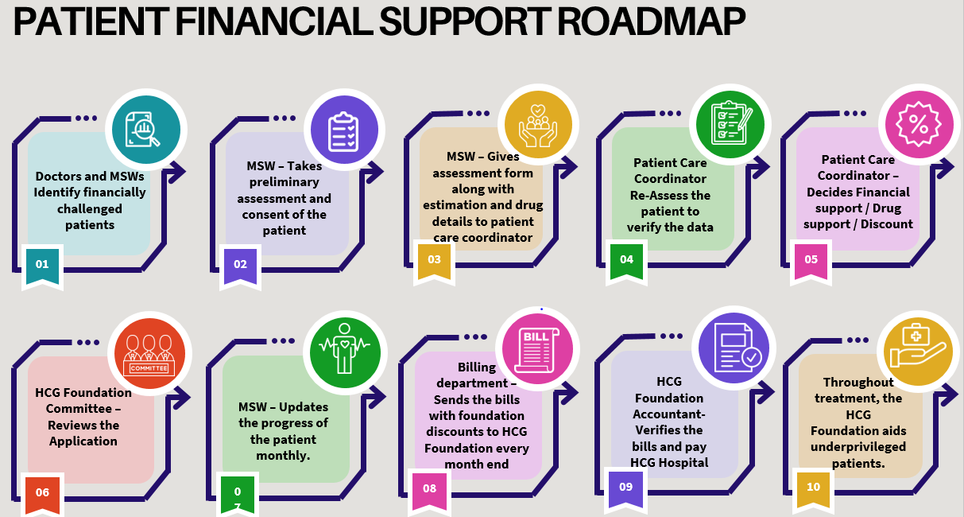

3. Background /Rationale of the Project:
Cancer remains one of the leading causes of premature death in India, ranking either first or second among the primary causes of mortality before the age of 70. Despite medical advances, a diagnosis of cancer often becomes a life-altering financial burden—especially for families in lower socioeconomic groups. Alarmingly, nearly 6 crores (60 million) Indians are pushed below the poverty line every year due to the overwhelming out-of-pocket expenditure on cancer treatment. This reflects not only a public health crisis but also a deep-rooted issue of health inequity.
Treatment for cancer involves prolonged, multi-disciplinary, and expensive medical care, including chemotherapy, radiation therapy, surgery, bone marrow transplants, immunotherapy, and continuous diagnostic testing. On average, full treatment can cost between ₹2 to ₹10 lakhs, a cost prohibitively high for most low-income families. Government schemes only partially cover these costs and are often inaccessible or insufficient, leaving a significant treatment gap for the underprivileged.

4. Theory of Change for the Patient-Aid Program

5.Objectives of the Project (Overall and Specific):
Objective | Strategy to achieve the objective
Provide Financial Assistance for Quality Cancer Treatment to Economically Marginalized Patients | - Identify patients through hospital social workers and doctors.  - Conduct financial and social background verification by MSWs and Patient Care Coordinators.  - Provide case-based financial support, ensuring critical need is prioritized.  - Partner with HCG hospitals to offer discounted treatment packages.

- Activities proposed during the Project-

Phase number | List of activities proposed during the phase
- Doctors and MSWs – Identify financially challenged patients taking treatment at HCG Hospital.
- MSW – Fills out preliminary assessment form, explains about HCG Foundation to the patient and family, collects supporting documents (identity copy, BPL or similar document, treatment estimation, photos, and consent form), and informs the HCG Foundation Patient Care Coordinator
- HCG Hospital provides subsidized treatment estimation for Foundation patients on Surgery, Radiation, and BMT packages.
- Patient Care Coordinator – meets the patient and family and verifies the financial situation through interviews with the family members. Also, a thorough background check will be conducted by the Patient Care Coordinator.
- HCG Foundation Committee – reviews the documents and patient story and decides the financial support.
- HCG Foundation team – raises funds for the patient if needs more funds.
- HCG Hospital Provides discounts to HCG Foundation-approved patients at the time of billing.
- HCG Foundation pays the approved discounted bill amount to the hospital and the Patient pays the remaining amount.
- MSW – Updates the progress of the patient and next admissions.

- Proposed Output/Outcome of the project:

- Minimum 100 economically disadvantaged patients supported for cancer treatment.
- Reduced treatment abandonment due to financial constraints.
- Increased survival rates due to early and consistent access to care.

- Monitoring and Evaluation Plan

There will be a rigorous process for evaluating and monitoring this project. Our hospitals have highly efficient documenters. Each documenter prepares and administers a pre-project questionnaire/ form. The results are evaluated and shared with the head office. The patient coordinator at HO analyses the questionnaire and prepares a project report. The coordinator also visits with the patient and attending doctor to monitor the patient’s health during and after the treatment/project. The coordinator will report any deviation from the project goals and appropriate action will be taken. Managers at the Foundation receive the hospital reports, the coordinator reports, and recommendations to monitor the project and make decisions if it is off target.

Area of focus | Indicator | Data source | Frequency
Access to Treatment | Number of patients supported with financial aid | Foundation beneficiary database | Quarterly
Financial Impact | Average % of treatment cost covered per patient | Bills, payment receipts | Quarterly
Health Outcomes | Number of successful treatment completions (remission/stabilization)(as applicable) | Discharge summaries, doctor reports | Quarterly

BUDGET DETAILS-

TOTAL Budget: ₹200,00,000
100 economically disadvantaged will be supported with a maximum 200,000 (Rs. 2 lacs) per patient for Radiation, Chemotherapy, Surgery, BMT, Immunotherapy, and other Cancer tests and treatments.

Budget details

SL No | Description | Estimated Cost/ Year  Amount (INR)
1 | Patient Financial Support | 190,00,000
2 | Admin and Project implementation cost | 10,00,000
 | Total | 200,00,000

DURATION OF THE PROJECT

This program will financially assist more than 100 patients to receive cancer treatment from 1st January 2026 to 31st December 2026. Driven by a focused mission, our organization is dedicated to providing financial support to as many cancer patients as possible. With your support, we can continue this critical work and closer to achieving equitable healthcare for all.

